2025-26



Committee on Committees External Chair

Transition Report

By Spring 2026 External Chair

LETTER
Mic check… Is this thing on? Hello new External Chair (Oliver)! This is your lovely, amazing, super cool also new External Chair Shuyi 😜~

As you may or may not know, I was appointed to this position following the graduation of our former EC so I wasn’t very familiar with the role and had to play catch up as well. Additionally, the EC will be taking on some new tasks next year (mainly the appointment/resignation process), which I am not too familiar with myself.

Anyways, just look at the rest of this doc and reach out if you have any questions!

SETUP
First, log into the email and update the email signature with your name !!
Current log-in info
Email: as-externalchair.coc@ucsb.edu
Password: EC202324_def
2-step verification:
Reach out to shuyi.sum@gmail.com / (510) 502-4064 if having trouble logging in
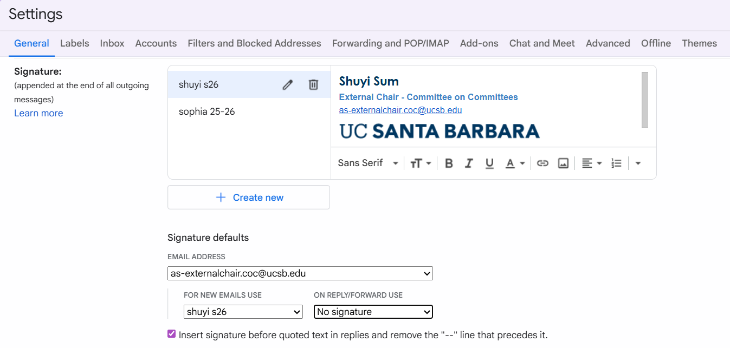
- Update the 2-Step Verification with your number !!
→ Manage Google Account
→ Security
→ 2-Step Verification Phones

Overview of main duties (Legal Code)
- Duties and Responsibilities of the Committee External Chair:
  - Ensure that the responsibilities of the Vice Chair, Internal Liaison, Shared Governance Coordinator, Internal Climate Coordinators and Outreach and Recruitment Coordinators are met.
→ aka keep the board in check!
  - Report at the three Senate meetings each quarter including the Senate meeting immediately following a meeting of the A.S. Assembly.
→ not really a thing anymore, just pretend this says State of the Association
  - Work with the Committee to schedule, advertise, and attend interviews of applicants for A.S. Committee positions (when needed) and student representative positions on Academic Senate and Administrative Advisory Committees.
→ all members should be doing this
  - Shall be responsible for coordinating an Association wide Week of Welcome recruitment effort in the fall quarter as well as a job-fair to recruit in the Spring quarter.
→ idk if this is a thing anymore, but would be cool if CoC actually did this!
  - Hold at least five (5) regular-posted office hours per week.
→ you might never need to do this
  - Shall be responsible for the Committee’s Social Media presence in collaboration with the Outreach and Recruitment Media Coordinators.
→ O&R should do the majority of this
  - Works with the chairs of A.S. entities to ensure necessary membership is met.
→ the main role of CoC overall, send lots of emails !
  - Chair all of the Committee on Committees meetings with the Internal Chair.
→ self explanatory
  - Be an active member of the Office of the Internal Vice President.
→ keep in touch with the President and Internal Vice President (2016-27 President EJ Raad should be chill with us bc he was formerly CoC)
  - Be a non-voting, Ex-officio member of all other A.S. entities.
→ I don’t even know what this means
  - Collaborate with the Internal Chair to plan quarterly retreats for the Committee.
→ self explanatory
  - Be responsible for the fiscal management of the Committee and in conjunction with the Internal Chair, shall prepare the Committee’s budget for the following year.
→ SUPER IMPORTANT !!
- Reference 2025-26 CoC Budget
  - Keep this updated along w/ the Internal Chair
  - Calculate expected honoraria each quarter before passing money for events/etc

WEBSITE
→ Keep open positions updated!!
- Check 26-27 OPEN AS Positions Recruitment spreadsheet
- Email BCUs weekly/biweekly to confirm updates/changes/closing positions.
- Follow steps in Website SOP

APPOINTMENTS
→ New task to be implemented, update this section with further instructions.
- See “Appointments and Resignations” folder in Drive
- Tentative:
- Check forms weekly for new submissions of Appointments or Resignations
- Compile list of names & BCUs, send to IVP (or someone else TBD)
- Once confirmed by IVP/other, update Appointments Tracker spreadsheet
ASUCSB 25-26 Appointments

INTERVIEWS
→ Keep BCUs updated on recruitment processes
- Aka just email the BCU’s Chair
“We have 5 interviews scheduled for next week for [positions].”
“We have deliberated on 3 interviewed candidates and we recommended [name] for [position].”
- Participate in interviews when available
- Work with Internal Chair to write interview questions if not provided by the BCU

A.S EVENTS
→ Attend A.S.-wide events, meetings, and gatherings as a representative of CoC
- Enjoy the free food and mingling!
- Quarterly Chairs Meeting (hosted by CoC)
- All CoC members should substantially participate in this
- External Chair will not have to speak unless the Internal Liaison cannot
- AS Quarterly Banquet
- Not mandatory, but good for at least 1 CoC member to attend each quarter
- Typically a guest speaker gives a 1-hour leadership training presentation + free food
- AS State of the Association (quarterly)
- Mandatory for either the Internal and/or External Chair to attend and speak
  - If neither Chairs can make it, the order goes: Vice Chair > Internal Liaison > O&R
- Chairs must fill out presentation slide for CoC, summarizing amount of budget spent that quarter + accomplishments/activities/events
- AS Awards Banquet (annually, end of Spring quarter)
- For funsies, all CoC members encouraged to attend if available

